**Week 1 Assignment**

Rishav Chaudhary

Presidential Graduate School, Kathmandu, Nepal

PRG401: JAVA

Professor Narendra Chaudhary

March 9, 2025

**W3 School Exercises**

**Syntax Exercise**

1. Question 1

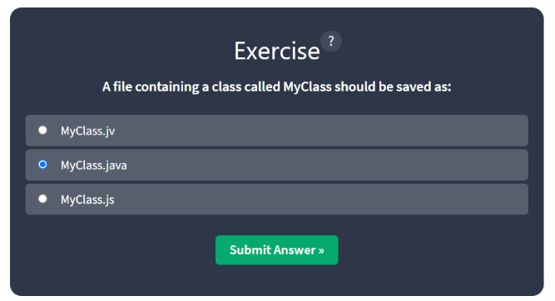

1. Question 2

1. Question 3

1. Question 4

1. Exercise Completed

**Comment Exercise**

**Output Exercise**

**Java Output Numbers Exercise**

**Java Variables Exercise**

1. Question 1

1. Question 2

1. Question 3

1. Exercise Completed

**Java Print Variables Exercise**

1. Question 1

1. Question 2

1. Question 3

1. Question 4

1. Exercise Completed

**Java Declare Multiple Variables**

1. Question 1

1. Question 2

1. Question 3

1. Exercise Completed

**Java Identifiers**

1. Question 1

1. Question 2

1. Question 3

1. Exercise Completed

**Java – Data Types Exercise**

1. Question 1

1. Question 2

1. Question 3

1. Exercise Completed

**Java Numbers**

1. Question 1

1. Question 2

1. Question 3

1. Question 4

1. Exercise Completed

**Java Boolean Data Types**

1. Question 1

1. Question 2

1. Question 3

1. Exercise Completed

**Java Characters**

1. Question 1

1. Question 2

1. Question 3

1. Question 4

1. Question 5

1. Exercise Completed

**Java Type Casting Exercise**

1. Question 1

1. Question 2

1. Question 3

1. Question 4

1. Question 5

1. Exercise Completed

**Classwork**

1. To Check for a positive number and grade A when 90-100, B when 80-89, C when 70-79 and D when 60-69

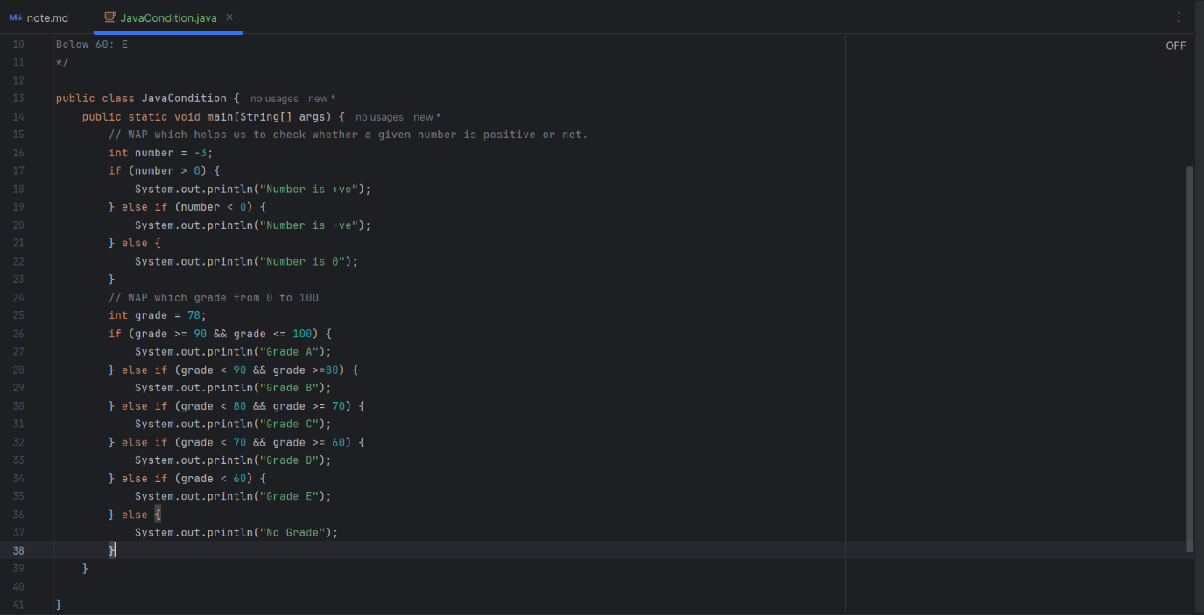

Output:

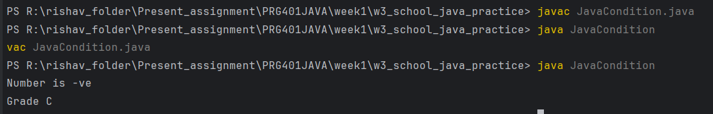

1. Use of Math Modules and its methods

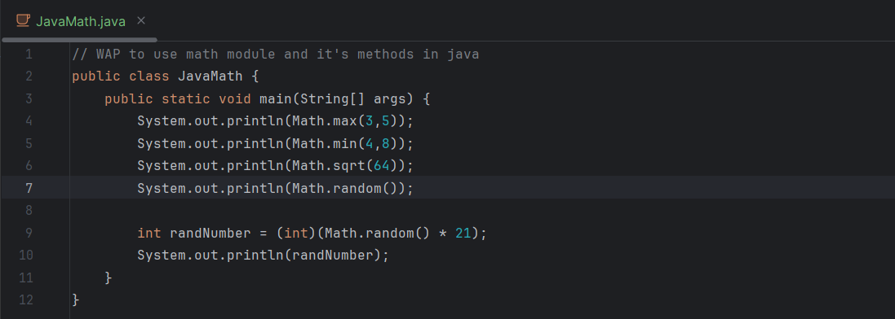

Output:

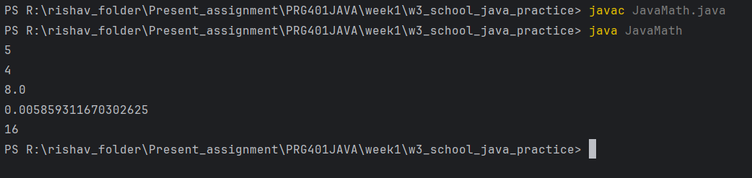

1. Asking user input using Scanner util, for USD and converting it to NPR and displaying it.

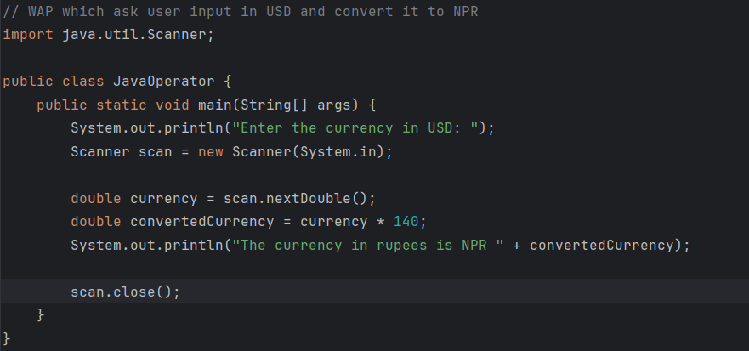

Output:

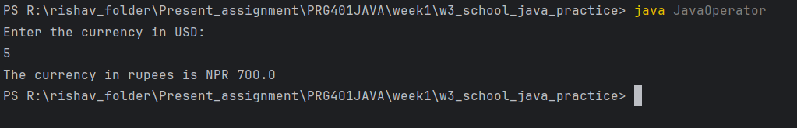

1. String Manipulation with StringBuilder to append, find out length, change to uppercase, concatenate, finding out char at index, equals and compare, and substring.

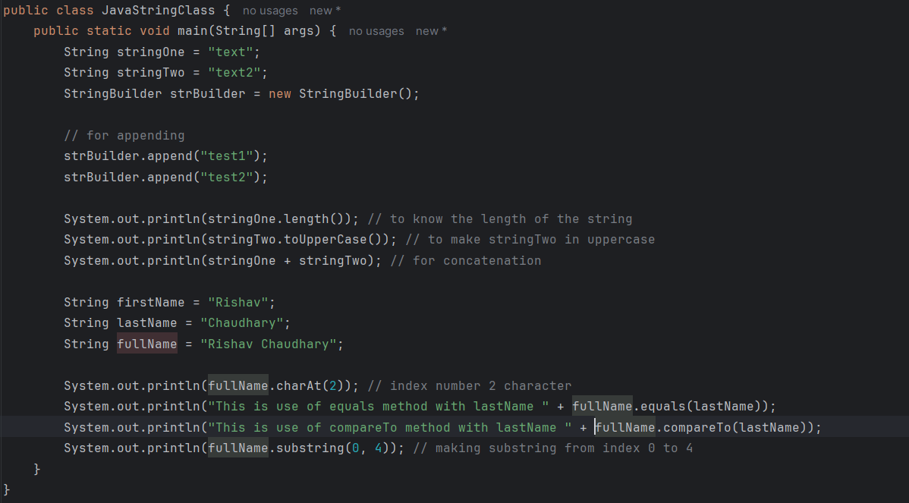

Output:

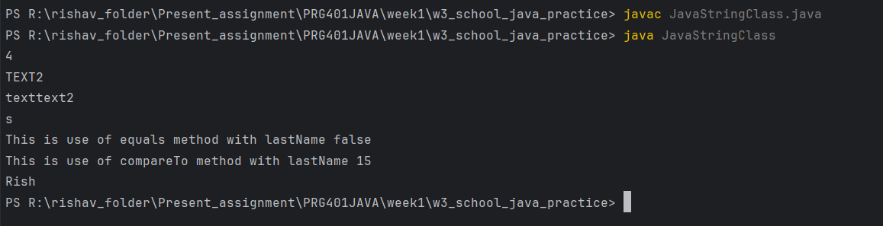

1. TypeCasting in Java

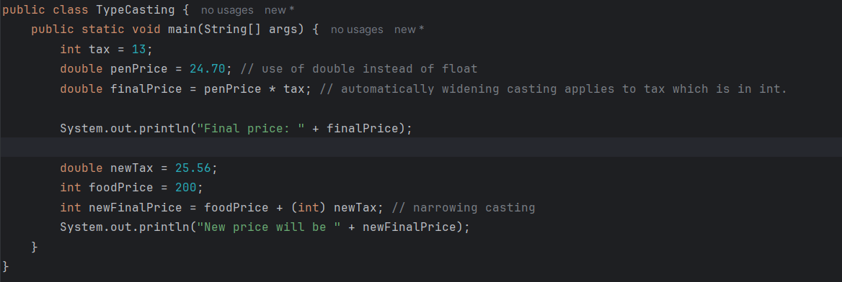

Output:

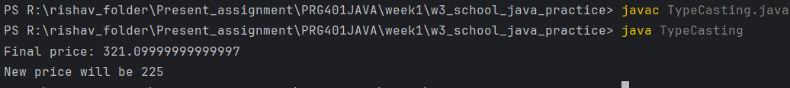

**References**

W3 Schools. (n.d.). *Java Tutorial*. Retrieved March 9, 2025, from <https://www.w3schools.com/java/default.asp>